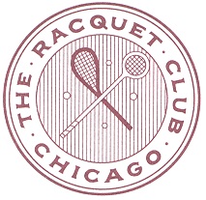
2018 Murray Sales, Tom Price & Denis Walsh Rackets Singles and Doubles
2018 U. S. Over 50’s Court Tennis Singles and Doubles
November 2nd – 4th
Registration Form
please fill out completely and email to: pros@racquetclubchicago.org BY OCTOBER 26TH
Call John, Conor or Steve in the Pro Shop with Questions – 312-642-1431
Name:
Daytime Phone:
Cell Phone:
Email:
Date of Submission:
A Credit Card will be a requirement upon Arrival

Events (Maximum 4 draws, 2 singles and 2 doubles) | Singles | Doubles | $
Murray Sales (Over 40’s Championships)
Tom Price (Over 50’s Championships)
Denis Walsh (over 60’s championships)
Tennis over 50’s Championships
PLAYER - 2 DRAWS - Entry into 2 Draws, Friday Evening Stag Dinner, Saturday Continental Breakfast, Saturday Evening Cocktails |  |  | $375
NON-PLAYING GUEST – Friday Evening Stag Dinner, Saturday Continental Breakfast, Saturday Evening Cocktails |  |  | $300
Each additional draw is $25. Prices include tax and service on all events. Entrants should be available Friday, November 2nd at 9:00am for play. Please note if you are available to play Thursday evening November 1st

Friday Evening Stag Dinner Honoring Willie Surtees

The Stag Dinner on Friday evening will be held in honor of Willie Surtees, former Rackets World Champion. We encourage everyone to attend this memorable event, even those who are not able to participate in the full tournament weekend.
Willie has been a prominent figure in the world of Rackets since the beginning of his career, winning the Rackets Public School Doubles in 1965 and Foster Cup in 1966. He arrived in Chicago in 1970 and joined the Racquet Club of Chicago and the University Club. He became World Champion in 1972, beating Howard Angus across two legs, winning 5 games to 4. Willie lost to Howard Angus the following year but regained the title in 1975 and held it for six years straight before losing to John Prenn in 1981.
Willie has lived in Wellington, Florida for the past 30 years, sporadically appearing at Rackets events throughout North America to reminisce about stories of the past and enlighten the youth of the game with his tales.
We welcome Willie back to the Racquet Club of Chicago to honor his Rackets skills, although one could argue that he perhaps excelled as much off the court as he did on it. In his day he was the epitome of a “swashbuckling” (to use Edward Ulmann’s word) Rackets player who reveled in the fun, excitement and camaraderie of the game.
Please join us for a great evening to honor a truly legendary figure in the history of the game of Rackets!
To confirm a seat at the dinner only, please RSVP to Melissa Zorio, head of catering and events at Melissa@racquetclubchicago.org

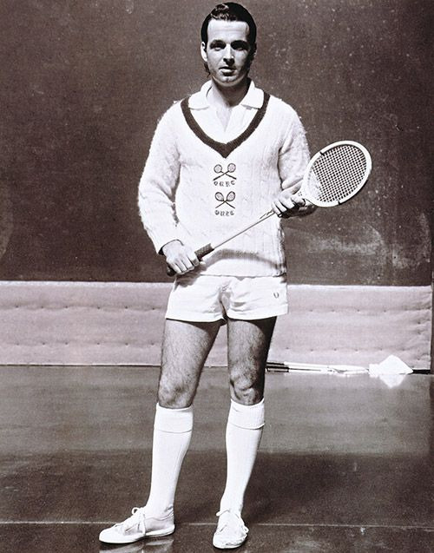
Willie Surtees circa 1968

