HADDEN TOMES 2017
Another huge success at The Tuxedo Club for the annual Hadden Tomes! 2017 saw a Game of Thrones theme infiltrate the racquet sports and social scene! Congratulations and thank you to Kim Kilgore and Laura Tillsley (event Chairs) as well as The Tuxedo Club’s General Manager Shelby LaCombe and Head Pro Tim Chisholm and their teams for all their hard work and preparation in making the 2017 tournament such a success.
45 players competed in HCP’d Court Tennis Doubles along with HCP’d Racket Singles & Doubles over three jam-packed days of play.
COURT TENNIS
The Round Robin format with different partners produced 8 players in both flights making the four ‘final’ rounds in Court Tennis.
In the first ‘final’, the crowd was treated to a barn burner of a match as Chris Heffernan & Marc Lewinstein (Newport) took on Steve Klepper & Paul Brooke. All ‘finals’ matches were handicapped 8 game pro sets with no-ad scoring and this one did not disappoint as it came down to the final point at 7-7, 40-all, before the Tuxedo pairing of Klepper & Brooke emerged victorious.
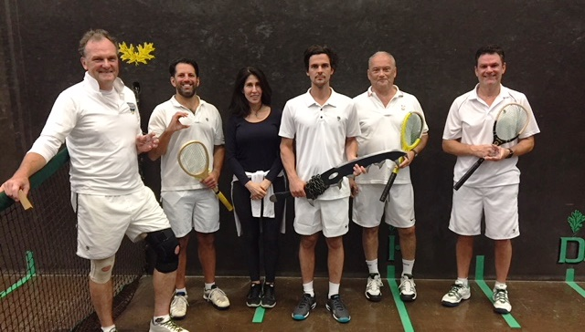
The second ‘final’ was an all Tuxedo affair as Laura Tillsley & Ernie Sink took on Dave Christensen & Stijn Van Nieuwerburgh. The kids were out in force for this match as all four participants had their little ones cheering them on! After a fairly close start to the match Christensen and Van Nieuwerburgh found their stride and ran away in the end to an 8-4 victory.
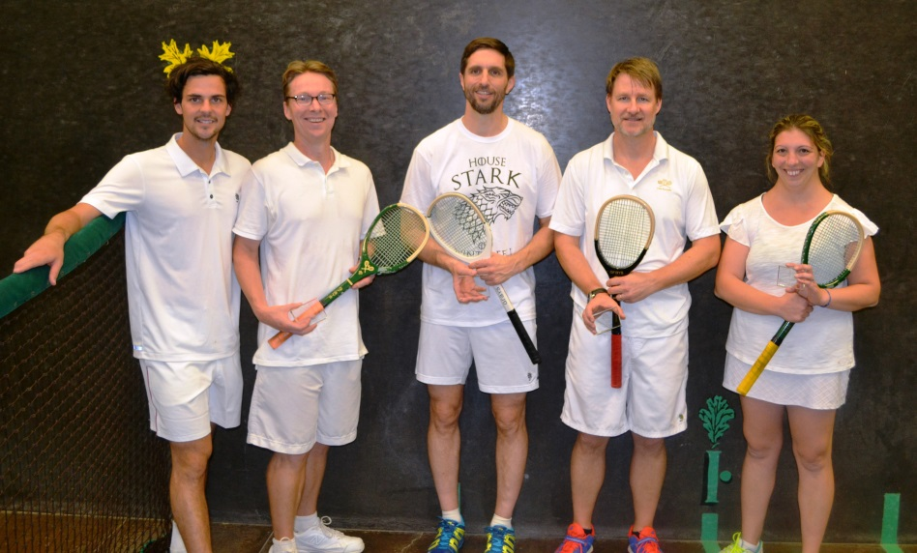
The third ‘final’ was a match-up pitting ‘youth’ against ‘experience’ as Tuxedo’s Co-Racquets Chairman Josh Scherer & Bill Barker (D.C.) took on Erik Barker (D.C.) & Sam Corbett (Wellington). Added intrigue with Father (Bill) vs. Son (Erik) and ‘bragging rights’ for the ride home to D.C. The youngsters were too strong and enjoyed a relatively straightforward 8-1 victory.
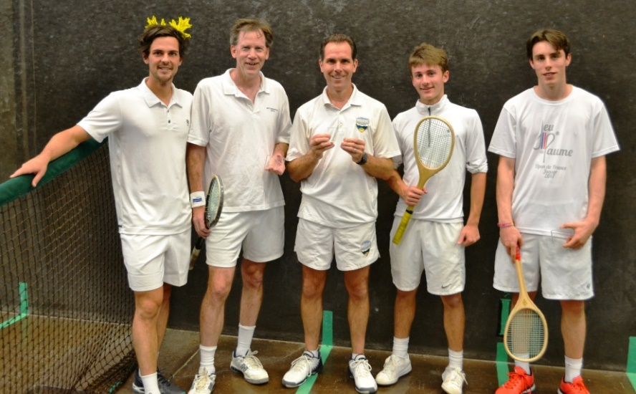
The final ‘final’ for Court Tennis was Peter Bender & Tyler Sloan (Boston) taking on Tuxedo’s Todd Yannuzzi & Houston Stebbins. The pair from Boston took all the key early points in this match and cruised to an 8-3 victory.
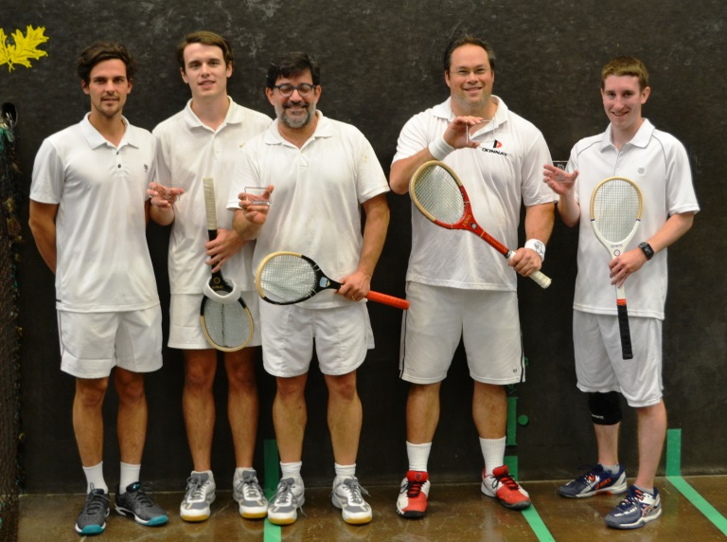
RACKETS
An added piece for HT 2017 was handicapped rackets singles and doubles which was universally well received by the players and spectators. 14 players competed in the two different rackets events during the 2017 Hadden Tomes weekend.
The singles players were placed into three four person round robin groups for the weekend. Congratulations to the following group winners:
- STOUT Division Erik Barker
- FOSTER Division Sam Corbett
- MALE Division Bill Barker
The doubles play consisted of two round robin groups with the winners to play a ‘final’ match. Dan Laukitis & Erik Barker emerged from a very tough group (3 teams with 2/1 win-loss records) based on having lost one less game than Greg Van Schaack & Bill Barker even after losing to Van Schaack & Barker 15/14 in the third game. The second group was won by Steve Klepper & Lucas Garvin.
Vegas would have lost money on the Final as the pre-match favorites (Klepper & Garvin) went down by the scores of 14/15, 15/12 and 13/15 to Laukitis and Barker. Congratulations to our 2017 HCP’d doubles champions…Dan Laukitis & Erik Barker.
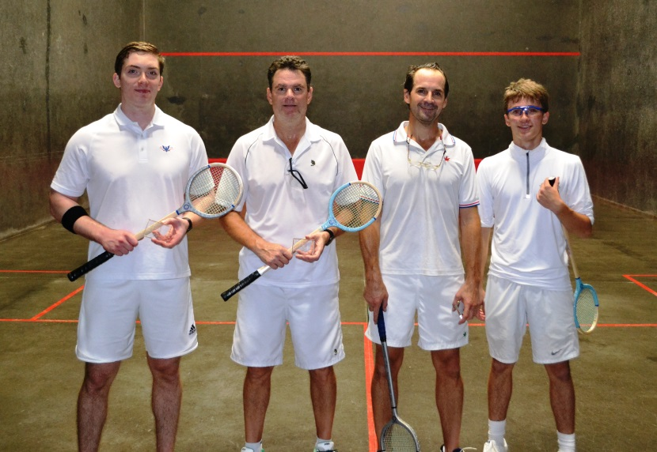
Make sure to put Hadden Tomes on your calendar for October 2018 as the committee has already decided on the theme and are looking to continually outdo themselves across the board.
SATURDAY EVENING
Historically, Hadden Tomes organizing committees have selected “safe bet” themes such as Oktoberfest, the 1970s and the 1980s. This year, the organizing committee, led once again by Kim Kilgore and Laura Tillsley, took a risk with a Game of Thrones-themed event. The risk paid off as almost all of the participants spent time and effort on their costumes and The Tuxedo Club went all out on decorations and dressing up the event staff (see photos below). A special thanks to Sue Sanford for providing costumes for the tennis pros – Josh Dodgson definitely won the award for the best Jon Snow. The Saturday night cocktails and dinner attracted approximately 110 participants and the post-dinner dancing and partying lasted well into the night.
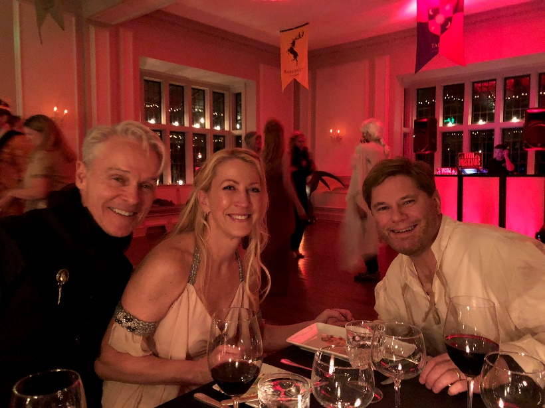
From right to left – Phil Tavani, Anne Madden, and Sean Madden
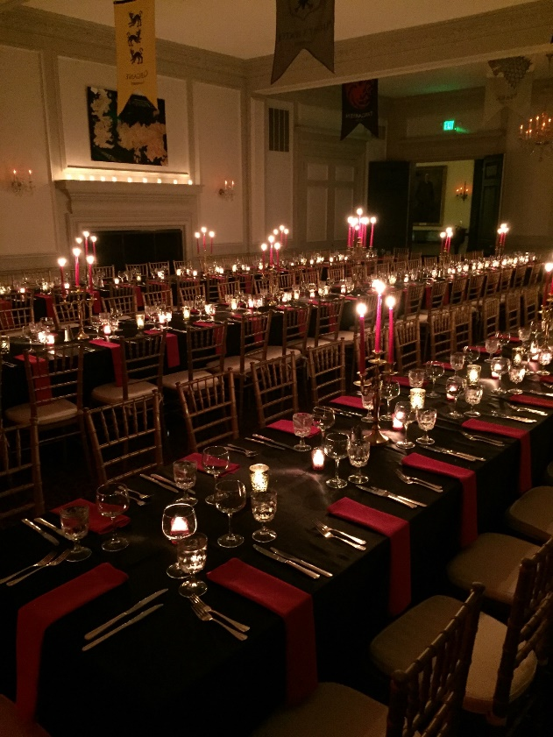
Castle Banquet Hall Seating with Banners from Each Family’s House
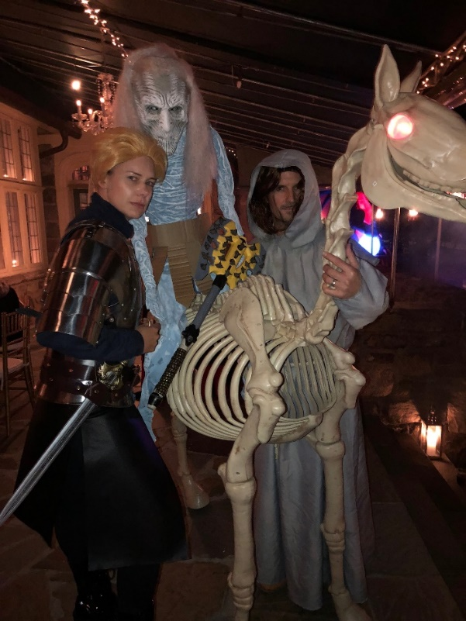
Lisa and Dan Laukitis
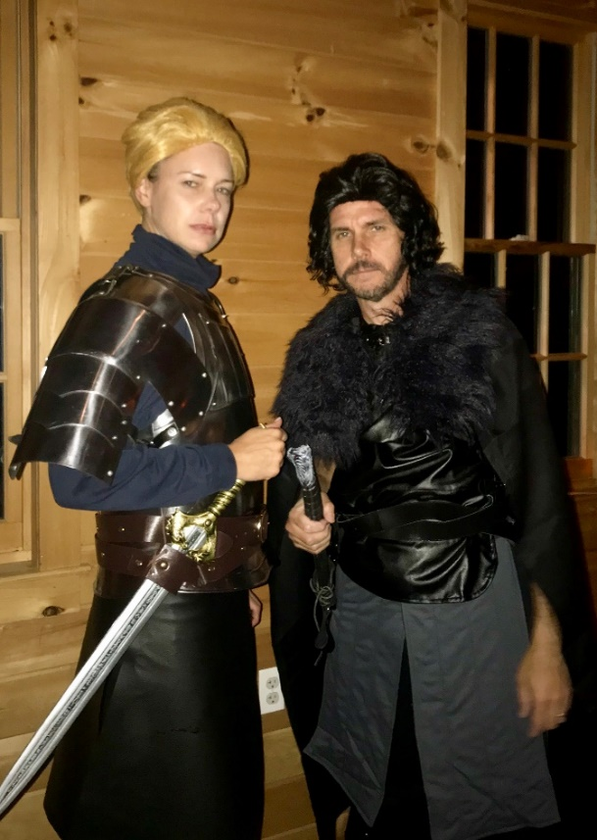
Lisa Laukitis and Josh Scherer
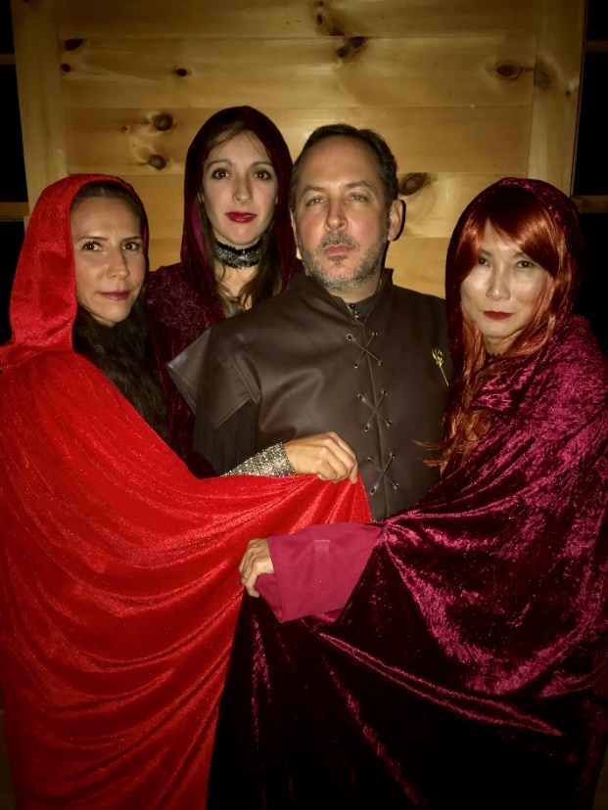
From Left to Right: Alina De Casteja, Xanthe Ranger, Charles De Casteja, and Rowena Scherer
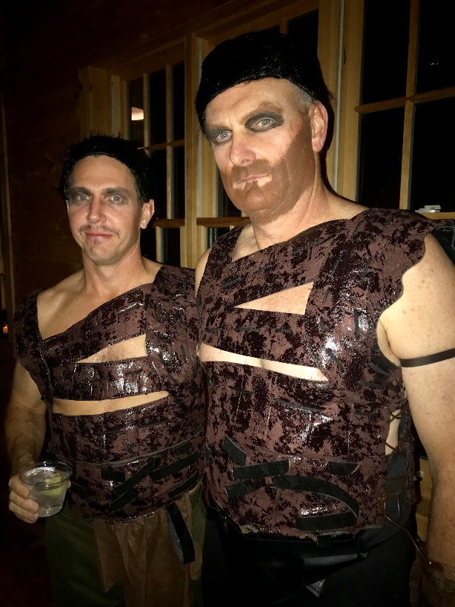
Greg Beard and Chris Heffernan

